Nama: Sheren Aulia Azahra
NIM: 103032400036
Kelas: IT-48-05
Jawaban Tugas Pendahuluan Modul 7
File stack.h
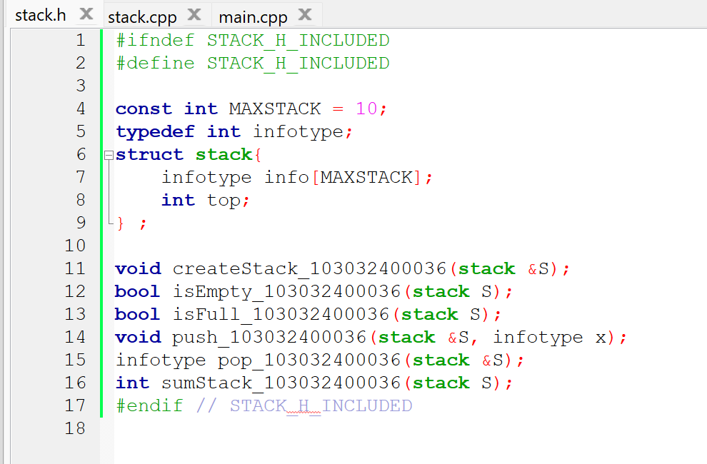

File stack.cpp
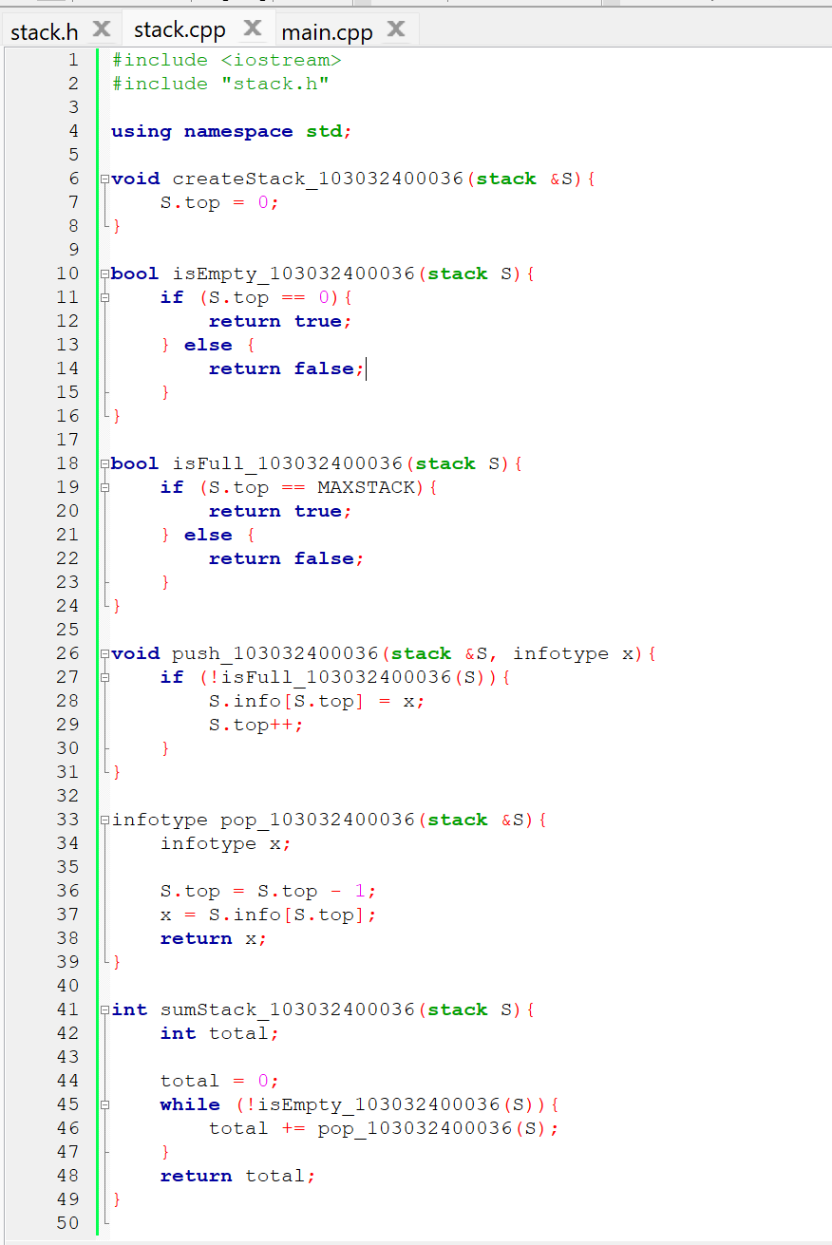

File main.cpp
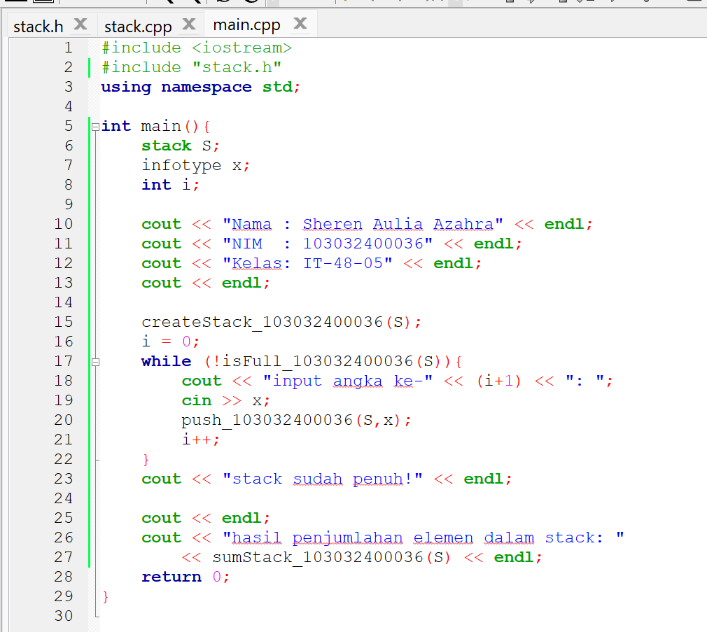
Output
